**DIGITAL SIGNAL PROCESSING TECHNIQUES FOR REMOVING NOISE FROM ECG SIGNAL**

**ABSTRACT**

In the great majority of systems today, signal processing is used for ECG analysis and interpretation. An ECG measures the electrical signal from the heart and can reveal important details about heart functionality in addition to detecting various heart diseases. But, ECG signals are sensitive to disturbances during this process. Its amplitude and duration can be distorted by different disturbances, which might occasionally result in a wrong diagnosis. So noise reduction serves as yet another crucial goal of ECG signal processing. MATLAB software can be used to eliminate Baseline Wander, Powerline Interface, and Electrode Motion Artifact noises in this project. Baseline Wander is a 0.5–0.6 Hz low-frequency noise. In order to improve peak detection performance, this study introduces a new peak detection method that can suppress noise and adjust to variations in ECG signal morphology. The suggested approach is founded on segmentation, time and amplitude thresholds, statistical false peak elimination, and median and moving average (MA) filtering (SFPE). To eliminate undesired noise and interference, the filters are first applied during preprocessing. A time axis (x-axis) threshold and an amplitude (y-axis) threshold are used to examine each segment of the data after it has been separated into smaller segments. Next, the erroneous peaks caused by any remaining noise are removed using the average peak-to-peak interval. Any peak that is spotted twice is removed, and a post-processing stage is introduced to look for missed low-amplitude peaks. The suggested strategy outperforms a number of cutting-edge approaches in the field when tested on the MIT-BIH arrhythmia and Fantasia databases.

**INTRODUCTION**

Heart is the one organ that is responsible for almost all of the processes in the Human Body. Major work of a Human Heart is pumping of Blood, Blood is the one thing that is responsible for every process in the entire Human Body. Blood contains Hemoglobin which is oxygen carrying protein, oxygen is the single most important thing that is required by the Human Body. So, the oxygen is supplied to various parts of the body through Blood. Without the Blood many organs that may be from the Brain to Hair everything will not work. We can’t put it in words, of “How much our Body depended on the Heart”, so, a healthy and hygienic lifestyle to be followed for a better working of the Heart. Health and many diseases are depended on functioning of the Heart, so, it became very essential task to record the functioning of Heart, for that, scientists came up with the idea of Electro-Cardiogram (ECG) Signals which records the activity of the Human Heart.

Electro-Cardiogram or ECG records the electrical activity of the Human Heart using the electrical signals produced by the Heart. Even though the ECG produces the electrical activity of the Heart, the resultant signal extraction become a hard and complex task where we are losing the vital information related to the Heart. So, there exists a number of techniques and methods for extracting the important information from the ECG signal. A typical ECG signal contains PQRST waves of which QRS are the most significant waves, so, extracting at least these three peaks are is an important task.

Even though there exists many techniques and methods to extract the QRS peaks from an ECG signal, the signal extraction is not an easy task, because it is susceptible to various noises. There exists a number of noises that degrade these QRS peaks. They are, Baseline Wander (BW) noise,

**Types of Noises**

**Baseline Wander**

Baseline Wander (BW) is caused because of a not proper electrode used while fetching the ECG signal. BW is a common type of noise that has to be taken care of every time fetching an ECG signal. As any other noise BW also affects the signal measurements which will be leading to a not accurate ECG signal measurement. The BW affects the Iso-Electric line that is the reference for measuring the ECG signal.

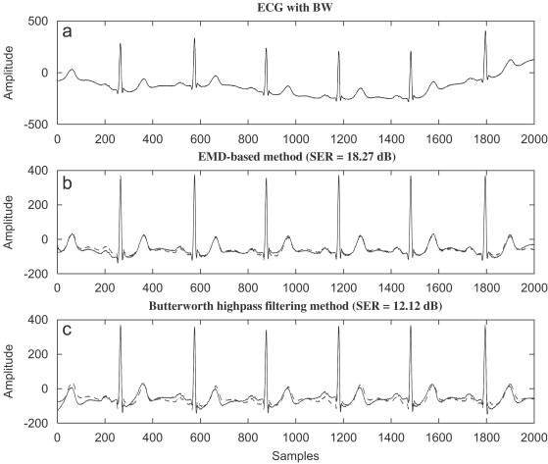

**Fig 1.1 ECG with Baseline Wander Noise and Filtered through EMD and Butterworth Filter**

Here, we can see that there exists many peaks in the filtered signal which was filtered using Empirical Mode Decomposition (EMD) and Butterworth Filter (BF). Likewise, the peaks are always be lost because of the presence of BW noise. Initially, BW can’t be identified but, we have to filter out that recorded ECG signal always to make sure we had not lost any of the QRS peaks or may be less significant P waves and T waves.

**Power Line Interference**

Power line interference is also a common type of noise in an ECG signal. This is caused because of the effect of voltage interferences. The AC currents will results in loops because of the cables of patient. There exists many reasons why a power line interference will occur that includes perfectly contacting cables and not using the better electrodes while capturing the ECG signal.

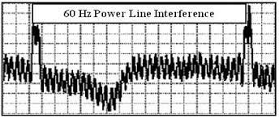

**Fig 1.2 ECG with Power Line Interface Noise**

We can observe that the distance between two R peaks of an ECG signal is 60 Hz, but in reality the distance between two R peaks is between 48-52 Hz or mostly 50 Hz. But, here, it is showing 60 Hz for distance between two R peaks. So, it became a quite challenging task to correctly capture the ECG signal without any disturbances for minimizing PLI noise.

**Muscle Artifact**

Muscle artifact is not common but a noise that occurs because of the shaking of the person while capturing the ECG. Shaking maybe due to many reasons, such as, Fever, Colder temperatures and maybe for any weaknesses. These result in wrongly recorded ECG. This is also an important concern but, it is quite uncommon.

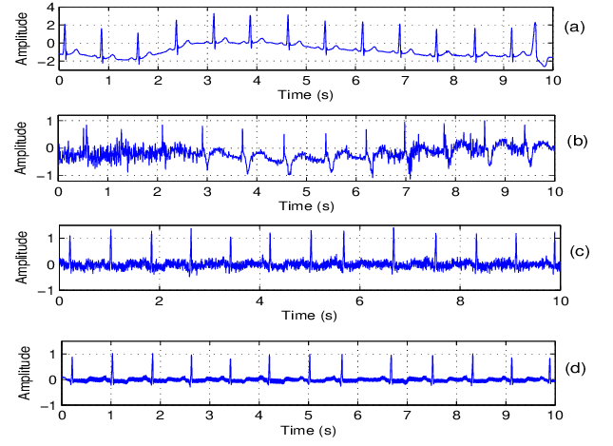

**Fig 1.3 ECG with Muscle Artifacts Noise and Filtered through various Filters**

As we can see, the signal is completely distorted which can result in a wrong interpretation of the condition of the Heart. Muscle artifact is maybe an uncommon but it become hard if it will be present. This maybe using any denoising technique that is available, but, if we use a best technique then it will result in a best signal.

There exists a number of techniques or methods for elimination or reducing these noises from not only an ECG signal but from any signal. They are, Fourier-Series and Fourier Transform, Wavelet Transforms and many filters such as, Butterworth Filter, Mean Filter, Median Filter, Moving Average Filter and so on.

**Fourier-Series and Fourier Transform**

Fourier series and Fourier Transforms are applied to a signal to convert or to represent that particular signal from time domain to frequency domain. Fourier Transforms are extended version of the Fourier series. Fourier series is applied to a signal which is Periodic in nature. Meaning the signal has to be repeat for a time period until infinity. Generally, periodic signals have a time period which is known as, Fundamental Time Period, up to which a signal is periodic and that instant of time period will repeat over the entire signal with a kind repetition. So, Fourier series is only to applicable for Periodic Signals other than that are not applicable in Fourier series. So, to apply Fourier series for a Non periodic signal that is aperiodic signal the modifications were done on the Fourier series giving rise to the Fourier Transforms. Fourier Transforms are applicable for Non periodic signals as well as Periodic signals. The main criteria is a signal should be Absolutely Integrable over a time period or may not be. There exists a conditions known as, Dirichlet conditions that need to be satisfied for the application of Fourier Transforms.

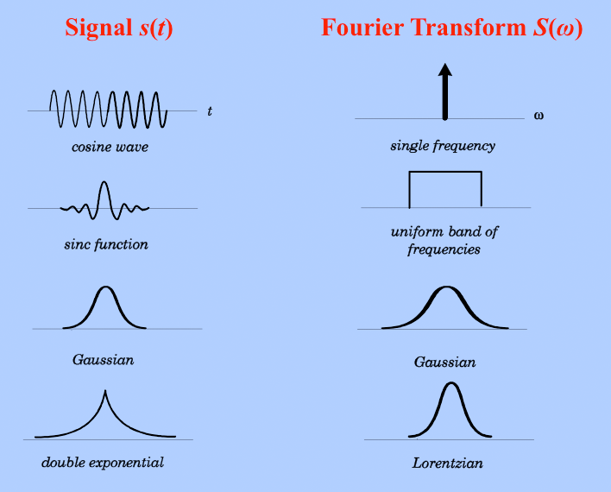

**Fig 1.4 Different types of Fourier Transformations**

**Wavelet Transform**

Wavelet Transforms are the simplest and most widely used representation of a signal. Representation of a signal in wavelets is an easiest way to apply any operations on the signal. During, Fourier series and Fourier Transforms the signal representation is somewhat hard and application of any operation over the signal is also complex. So, scientists came up with an idea of modifying those Fourier Transforms and given rise to the Wavelet Transforms. Wavelets can be applied to any type of signal that may or may not be periodic. The signal need not to be absolutely integrable over a time period. Wavelets are several types, such as, Haar, Daubichies, Symlet and Coiflet. Haar wavelet is once a widely used wavelet that ruled during initial days of the wavelets introduction, but, due to the emergence of remaining new wavelets that are modified and easiest in implementation made the Haar wavelet left out for special purposes only. There exists many wavelets namely, Daubichies with 4 and 8 levels for decomposition. Symlet with 4 and 8 levels for decomposition. Coiflet with 4 and 8 levels for decomposition.

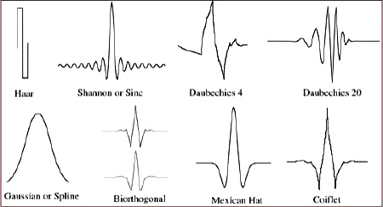

**Fig 1.5 Different types of Wavelets**

There exists a number of noises that corrupts the ECG signal in a different manners. Some degrade the signal’s strength, some completely the spectral characteristics of the signal and some completely change or destroys the signal. Such as, Baseline Wander, Power line interference and motion artifacts. The motion artifacts are due to the motion of the person during the process of fetching the ECG from the person. Person’s movement can affect the signal’s quality from a low level to a considerable level or even higher. The power line interference is a typical type of noise that occurs due to the interference of electrical signals that does not belongs to the activity of the Heart. The interference of the signals that are captured by the ECG during the initial process. Baseline Wander is a type of noise produced in ECG signals because of the poor equipment or presence of any disturbances in the middle and presence of any electrical equipment near to the person who’s taking the ECG test.

**Statistical False Peak Elimination (SFPE)**

The Statistical False Peak Elimination (SFPE) is a statistical analysis of the extracted ECG segments. The technique uses statistical thresholds and selection to eliminate any false peaks present in the segments. After, the segmented ECG signals are extracted, the SFPE uses the pseudo true peaks for analysis and calculates the difference between the peaks that lie adjacent and a mean peak to peak difference as well as their weights are also calculated. After, all the statistical analysis of the segments it uses a search back stage for detecting any missed out true peaks in the ECG signal segment. The thresholding technique yields several true positive peaks at this stage. Later, a search back stage is employed for detecting the missed out peaks. Search back works like a feedback for the system where it checks once again for the remaining missed out true peaks.

**LITERATURE REVIEW**

**[1] T. Sharma and K. K. Sharma:** Since the QRS complex is the electrocardiogram's (ECG) most noticeable feature, its identification is necessary for distinguishing the ECG's other waves and segments and for extrapolating clinically relevant data. Variable QRS morphologies, noise, artefacts, and interference from tall and pointed P- and T-waves all contribute to the difficulty of QRS detection. In this study, we suggest a novel method for QRS detection that involves weighted total variation (WTV) denoising before preprocessing the ECG. The amount of smoothing is determined by the regularisation parameter in the WTV minimization, which is based on a local estimation of noise in the signal block under consideration. The denoising is hence locally adaptive.

**Summary:** Analysed about the QRS peaks and studied about different noises in ECG using weighted total variation

**[2] K X. Lu, M. Pan, Y. Yu:** Globally, cardiovascular disease is the leading cause of death. The automatic electrocardiogram (ECG) analysis technique, whose initial stage is QRS identification, is crucial in achieving a speedy and accurate diagnosis. The QRS complex detection threshold approach is renowned for its quick computation and minimal memory usage. Threshold algorithms are easily adaptable to portable, wearable, and wireless ECG systems in this mobile era. The threshold algorithm's detection rate still has to be improved, though. This research reports an enhanced adaptive threshold technique for QRS detection. Preprocessing, peak discovery, and adaptive threshold QRS detecting are the primary components of this technique. On the MIT-BIH, the detection rate is 99.41%, the sensitivity is 99.72%, and the specificity is 99.69%.

**Summary:**

Analysed about the QRs peaks detection using statistical thresholds and detected the QRS peaks from an ECG signal

**[3] R. M. Rangayyan**, **John Wiley & sons:** Physiological processes are intricate phenomena that may involve nervous system or hormonal stimulation and regulation, inputs and outputs that may take the form of substances, neurotransmitters, or information, and mechanical, electrical, or biochemical actions. Most physiological processes are accompanied by signals that represent their nature and activities, or they manifest as signals themselves. These signals may be biological, such as hormones and neurotransmitters, electrical, such as potential or current, or physical, such as pressure or temperature.

**Summary:** Analyzed about the Physiological processes involved in QRS peak detection from an ECG signal and detected them

**[4] J. Pan, W.J. Tompkins:** We have created a real-time method for the recognition of ECG signal QRS complexes. Based on digital studies of slope, amplitude, and width, it accurately distinguishes QRS complexes. The various types of interference found in ECG signals are reduced by a specialised digital bandpass filter. Due to the usage of low thresholds made possible by this filtering, detection sensitivity has increased. Periodically, the system automatically modifies thresholds and settings to account for variations in the heart rate and QRS shape of the ECG. This technique properly identifies 99.3% of the QRS complexes in the common 24 h MIT/BIH arrhythmia database.

**Summary:** Analyzed about the QRS peaks of an ECG signal and extracted them using Arrhythmia databases and MIT/BIH databases

**[5] J.D. Drake, J.P. Callaghan:** Due to the close proximity of the collecting sites to the heart and the volume conduction properties of the ECG through the torso, trunk electromyographic signals (EMG) are frequently polluted with heart muscle electrical activity (ECG). Few research have directly compared various strategies for a given set of data or measured ECG removal procedures in contrast to an uncontaminated EMG signal (gold standard or criteria measure). Given the ubiquitous usage of EMG, it is imperative to comprehend the effects of both untreated contaminated EMG and ECG removal procedures on the amplitude and frequency parameters. This study's objective was to assess four groups of recently developed and frequently applied methods for removing ECG contamination from EMG signals. ECG records at two different intensities.

**Summary:** Analyzed about the Both ECG and EMG signals and applied a same method for extracting the QRS peaks from the ECG signal

**EXISTING METHOD**

Since the QRS complex is the electrocardiogram's (ECG) most noticeable feature, its identification is necessary for distinguishing the ECG's other waves and segments and for extrapolating clinically relevant data. Variable QRS morphologies, noise, artefacts, and interference from tall and pointed P- and T-waves all contribute to the difficulty of QRS detection. In this study, we suggest a novel method for QRS detection that involves weighted total variation (WTV) denoising before preprocessing the ECG. The amount of smoothing is determined by the regularisation parameter in the WTV minimization, which is based on a local estimation of noise in the signal block under consideration. The denoising is hence locally adaptive. When smoothing, the weights are chosen to favour maintaining QRS complexes over P- and T-waves. Thus, despite the fact that P- and T-waves have overlapping spectra with the QRS complexes, the approach can concurrently minimise both the lower frequency interference from P- and T-waves and the higher frequency noise. The MIT-BIH arrhythmia database is used to test the suggested method, which provides better detection accuracy than known and cutting-edge methods. Due to the method's minimal computing load, it can be utilised for both real-time block-by-block processing mode and quick offline QRS detection in extended length ECG records. Sensitivity, positive predictivity, and detection error rate have respective average values of 99.90%, 99.88%, and 0.23%. A method for QRS detection using weighted total variation denoising is proposed. The technique can suppress noise spectrally overlapping with the QRS complexes. The method has low computational load and is real-time implementable.

Similar to most other QRS detection techniques, the proposed method consists of two stages: a preprocessing stage and a peak detection stage, as shown in the block diagram in Fig. 1. The preprocessing is carried out block-by-block, the size of each block being N, to have a local estimate of noise in the denoising operation. The preprocessing is carried out in a series of steps that aim at suppressing the noise peaks and the P- and Twaves, and accentuating the QRS complexes. Since the preprocessing is done block-by-block, edge effects can occur after filtering, because of abrupt truncation, and hence, false peaks can be detected at the block boundaries. To avoid this issue, symmetric padding is done on the blocks on both sides before filtering, by using reflecting boundary conditions. The padding is discarded after the filtering operation. Also, before application of the proposed algorithm, the signal is clipped at ±11 mV, to limit the amplitudes of possible artefacts. The ECG signal amplitude is much lesser. After preprocessing, a smooth envelope is obtained, in which peaks are detected. These peaks are used as guides to determine the actual Rpeak locations in the ECG signal. Each of the steps are detailed in the following subsections

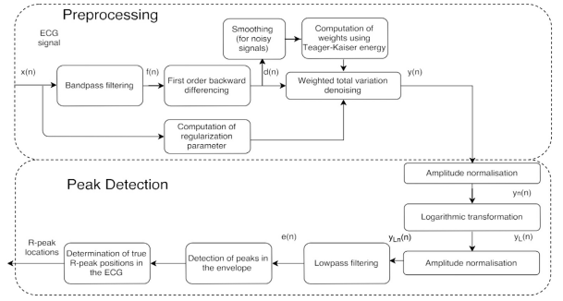

**Fig 2 Block Diagram of Existing Method**

**Bandpass filtering and differentiation**

The ECG signal is first bandpass filtered to select the frequency range [6 22] Hz, in order to select most of the QRS energy and eliminate the out-of-band noise such as power line interference, which occurs at the power line frequency of 50/60 Hz and baseline wander, which lies at frequencies less than 1 Hz. This also diminishes the amplitude of the lower frequency P- and T-waves. The bandpass filter is designed as a constrained least squares FIR filter of order M. In designing this filter, it is not required to explicitly define the transition bands in the magnitude response.

**Weighted total variation Denoising**

The signal which is obtained after bandpass filtering and differentiating the ECG, still contains noise, which lies in the same frequency range as the QRS complexes. Hence, this noise is difficult to remove using the linear Fourier transform based filtering techniques. Muscle noise (Electromyogram) is a major source of this noise. To suppress this noise without smoothing out the QRS complexes, optimization techniques such as TV filtering can be used.

**DISADVANTAGES:**

1. The method is not very good extracting peaks.
2. The method doesn’t consider of very low peaks.
3. The method is not effective at detection of q and s peaks.

**PROPOSED METHOD**

Numerous types of sounds can be found in electrocardiogram (ECG) readings, including baseline wander, powerline interference, electrocardiographic (ECG) noise, and electrode motion artefact noise. Baseline drift is a 0.5 to 0.6 Hz low-frequency noise. A high-pass filter with a cut-off frequency of 0.5 to 0.6 Hz can be used to eliminate it. Later, Statistical False Peak Elimination (SFPE) using Amplitude and Time Thresholds will be implemented. The SFPE involves three stages such as, Pre-Processing Stage, Peak detection Stage and a Post Processing Stage. Signal noise is removed in the first stage that is the pre-processing stage. The detection of the extracted peaks will be done in the second stage known as Peak Detection Stage. Later, the Search-back stage is attached in the post-processing stage where, the missed peaks are again searched and detected for making the technique even better.

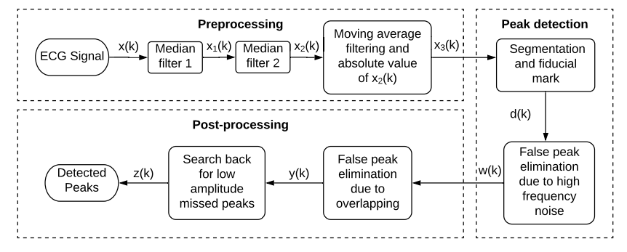

**Fig 3.1 Block Diagram of Proposed Method**

**Pre-Processing Stage**

Pre-Processing Stage is started by the capturing of ECG signal from the person who maybe a patient too. The Captured ECG signal will be transferred to Filtering stage for filtering the noise present in the ECG signal. The Filtering stage is a convolution of two cascaded Median Filters with a Moving Average Filter. For making the noise removal even better. The Median Filters in combination with a Moving Average Filter results in a better Noise reduction than the existing techniques.

**Median Filter**

Median Filter is a type of filter used for eliminating the noise from the signal that maybe a 1D, 2D and 3D. The median filter chooses an area where is the noise is present. The area can be detected in such a way, that, the deviation of the signal value at that instant will be much higher from the remaining instants that are their neighbors. The median filter then calculates the median of the particular area, then, the value or instant which has a higher deviation will be replaced by the median value. The process is implemented on all the instants of the signal and the value that deviates much will be replaced regularly with the median of that particular chosen area. In this way, the median filter filters out the noise from the signal. But, here, we have implemented the median filters with cascaded which makes the noise elimination even better. The two stage median filtering results in a great way of suppressing the noise.

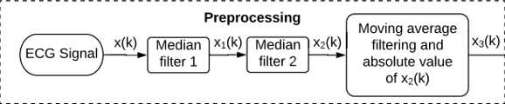

**Fig 3.2 Filtering Stage**

**Moving Average Filter**

Moving average filter is also typical filter that is used to eliminate noise in signal that maybe, 1D, 2D and 3D. Moving average filter also selects an area which has a high deviation from their neighbors. The average will be calculated by considering their neighbors too. Later, the instant of the signal that has a high deviation from their neighbors in a chosen area will be replaced with the average value of that particular area. The process is applied to all of the areas where there is a deviation. The moving average filter is called a moving average because the average value will be moved through entire signal till the noise the suppressed to a great extent or at least to a desired extent. The filtering stage convolved the cascaded median filters with the moving average filter for reducing the noise to a greater extent. The combination of filtering reduces the noise to a greater extent and much better than the existed methods or techniques.

**Peak Detection Stage**

The noise filtered ECG signal will be sent to the Peak detection stage where the peaks are detected using Amplitude and Time Thresholds. The thresholds for estimating the QRS peaks. The thresholds are done based on the statistical analysis of the ECG signal. The thresholds are the values that result in the typical QRS peaks or waves. The particular Q peak or R peak or S peak will have a regular time instants or lengths or heights. These can be used to threshold to extract the near exact Q or R or S peaks. The peak detection will be more better whenever there is better thresholds. For that we have to remove the noise at a greater value. The R peaks are the most and easily detectable among all of the ECG peaks. The typical tallest peak or that which peak that has highest amplitude in an ECG signal is always an R peak. So, the R peaks are easily be extracted and can be used for reference in estimating the other peaks. Like the difference between the two R peaks and the threshold difference between the QR peaks as well as RS peaks. So, the threshold will result in better way, if the R peaks are detected perfectly.

**Post Processing Stage**

Post processing stage involves the search back stage which once again searches for any of the missed out peaks in the previous stages. The thresholds may not always result in a better extraction or estimation of the true peaks or all peaks. So, a search back stage once again searches for the missed out true peaks. Search back stage is a new revolution in the ECG QRS peak detection which makes the Peak detection even more better when considering a QRS peak detection. The typical QRS peaks are almost recovered from the signal through this way. Thresholding through amplitude and time instants result in a better way for recovering the true QRS peaks as many as possible. The statistical false peak elimination with two stage filtering with a cascaded median filtering and moving average filter, peak detection through statistical thresholds of time instants and amplitude values and search back stage for searching the truly missed out peaks is a whole new method for recovering the QRS peaks from a typical ECG signal.

The Statistical False Peak Elimination (SFPE) is a statistical analysis of the extracted ECG segments. The technique uses statistical thresholds and selection to eliminate any false peaks present in the segments. After, the segmented ECG signals are extracted, the SFPE uses the pseudo true peaks for analysis and calculates the difference between the peaks that lie adjacent and a mean peak to peak difference as well as their weights are also calculated. After, all the statistical analysis of the segments it uses a search back stage for detecting any missed out true peaks in the ECG signal segment. The thresholding technique yields several true positive peaks at this stage. Later, a search back stage is employed for detecting the missed out peaks. Search back works like a feedback for the system where it checks once again for the remaining missed out true peaks.

This approach is developed using three distinct stages, unlike the majority of algorithms in the literature. First, as depicted in, the preprocessing stage removes undesired noise and artefacts while reducing the impact of P and T waves. The second stage's purpose is to divide the ECG record into more manageable chunks and perform peak identification on each of those chunks independently. In this phase is known as peak detection. Each record is separated into equal segments with a maximum of 25000 samples per segment, and very low amplitude peaks are removed using an amplitude axis cutoff. Now, a threshold for the time axis is determined by calculating the mean of the difference between neighboring peaks.

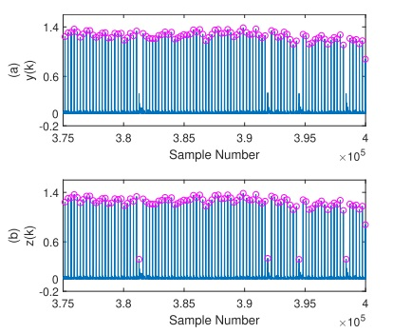

**Fig 3.3 Search Back Stage**

Finally, any missing peaks are found using a search back sub-stage that learns from the R-R difference over the whole ECG record. Here, x(k) represents the input ECG signal, x1(k) represents the signal after being passed through the first median filter, x2(k) represents the signal after being passed through the second median filter, x3(k) represents the signal after passing through the moving average filter and after absolution, d(k) represents the segmented signal, w(k) represents the signal that contains false peaks that are eliminated due to high-frequency noise, and y(k) represents.

Preprocessing begins by applying two median filters, the second of which has a window size that is twice as large as the first, to the entire record. It is possible to choose between window sizes of 50 ms and 100 ms and 100 ms and 200 ms. This is due to the fact that P waves appear 50–100 ms b The high-frequency sounds in the ECG record are muted using a moving average (MA) filter. For this, conventional techniques employ a number of filters. However, the peak information can be greatly reduced by utilizing FIR band-pass filters. A moving average (MA) filter of 20 samples is used to prevent this. The signal is shown after it has been processed by a moving average filter. In order to replace the selected sample, the filter reads samples that are 10 samples to the left and 9 samples to the right of it. It then computes the average of these 20 samples. A MA filter is a low-pass filter that is more effective at cutting down on high frequency interference and noise.

The 20-sample MA filter therefore the QRS complex and T waves appear 50–100 ms after the QRS complex. Segmentation and false peak elimination are the two procedures that make up this stage, where the ECG data is separated into, Depending on the number of samples, it may be divided into smaller portions. In order to find peaks, each segment is evaluated separately. The ECG signal from record 228 is depicted in part in displays the discovered peaks on the raw ECG signal, where the circles denote the peak locations, whereas shows the detected peaks on the absolute value of the mean envelope. These 20 samples will take its place at the location of the original sample. A low-pass filter called an MA is more effective in reducing high frequency noise and interference. 20 sample MA filter.

The record is now split into segments with M samples each following the completion of preprocessing. This is dependent on the length of the record, however the total number of samples used shouldn't exceed 25000 for processing to be quick and accurate. In order to more effectively adapt to the ECG signal's changing shape, it is thought to analyze smaller segments. The method is initialized sample so that the splitting of samples is automatic. A low-pass filter called an MA is more effective at cutting down on high frequency interference and noise. The MA filter with 20 samples, Each segment is dealt with separately in this stage. First, a fiducial mark vector, W, is constructed, which is a vector made up of all the local peaks in the segment with a minimum filter of 20 samples.

When the majority of the real positives have been found, there may still be a few peaks that the algorithm missed earlier because of their small amplitudes. Therefore, a second analysis of the segments from the segmentation stage is conducted. Here, it should be emphasized that a number of peaks have previously been disregarded as false peaks. Vectors L and P no longer contain those values for the associated segments, and as a result, their new lengths are f. The updated weights in vector L are now used to re-formulate vector D. The standard deviation of the peaks is determined through additional analysis of the vector L. Only if the standard deviation is less than or equal to 100 samples will the search backstage be initiated. This is to verify that there is no false trigger since some records are multiform, which means that they frequently modify the lengths of the intervals between their peaks. The updated weights in vector L are now used to re-formulate vector D.

**ADVANTAGES AND APPLICATIONS**

**Advantages:**

1. The SFPE algorithm is quite good at thresholding.

2. SFPE algorithm is effective in the case of low amplitude peaks.

3. SFPE algorithm is also effective in the case of removing noise that degrades the signal.

**Applications**

1. Applied in DSP applications.

2. ECG Peak Detection.

3. Bio-Medical Signal Processing.

4. Image Processing.

**HARDWARE & SOFTWARE REQUIREMENTS:**

**Software:**

• Matlab R2020a.

**Hardware:**

**Operating Systems:**

• Windows 10

• Windows 7 Service Pack 1

• Windows Server 2019

• Windows Server 2016

**Processors:**

Minimum: Any Intel or AMD x86-64 processor

Recommended: Any Intel or AMD x86-64 processor with four logical cores and AVX2 instruction set support

**Disk:**

Minimum: 2.9 GB of HDD space for MATLAB only, 5-8 GB for a typical installation

Recommended: An SSD is recommended a full installation of all Math Works products may take up to 29 GB of disk space

**RAM:** Minimum 4 GB but recommended 8 GB

**SOFTWARE**

Introduction to Matlab

What Is MATLAB?

The name MATLAB stands for Matrix Laboratory. The software is built up around vectors and matrices. This makes the software particularly useful for linear algebra but MATLAB is also a great tool for solving algebraic and differential equations and for numerical integration. MATLAB has powerful graphic tools and can produce nice pictures in both 2D and 3D. It is also a programming language, and is one of the easiest programming languages for writing mathematical programs. These factors make MATLAB an excellent tool for teaching and research.

MATLAB was written originally to provide easy access to matrix software developed by the LINPACK (linear system package) and EISPACK (Eigen system package) projects. It integrates computation, visualization, and programming environment. Furthermore, MATLAB is a modern programming language environment: it has sophisticated data structures, contains built-in editing and debugging tools, and supports object-oriented programming. MATLAB has many advantages compared to conventional computer languages (e.g., C, FORTRAN) for solving technical problems.

MATLAB abilities a family of add-on software program utility software application software program software utility software-unique solutions called toolboxes. Very essential to maximum customers of MATLAB, toolboxes assist you to studies and observe specialized technology. Toolboxes are entire collections of MATLAB abilities (M-files) that increase the MATLAB surroundings to remedy precise schooling of problems. Areas in which toolboxes are to be had embody signal processing, manipulate systems, neural networks, fuzzy correct judgment, wavelets, simulation, and hundreds of others.

It has powerful built-in routines that enable a very wide variety of computations. It also has easy to use graphics commands that make the visualization of results immediately available. Specific applications are collected in packages referred to as toolbox. There are toolboxes for signal processing, symbolic computation, control theory, simulation, optimization, and several other fields of applied science and engineering. MATLAB is an interactive system whose basic data element is an array that does not require dimensioning. The software package has been commercially available since 1984 and is now considered as a standard tool at most universities and industries worldwide.

Brief History of MATLAB:

Cleve Moler, the chairman of the computer science department at the University of New Mexico, started developing MATLAB in the late 1970s. The first MATLAB® was not a programming language; it was a simple interactive matrix calculator. There were no programs, no toolboxes, no graphics and no ODEs or FFTs. He designed it to give his student’s access to LINPACK and EISPACK without them having to learn FORTRAN. It soon spread to other universities and found a strong audience within the applied mathematics community. The mathematical basis for the first version of MATLAB was a series of research papers by J. H. Wilkinson and 18 of his colleagues, published between 1965 and 1970 and later collected in Handbook for Automatic Computation, Volume II, Linear Algebra, edited by Wilkinson and C. Reinsch. These papers present algorithms, implemented in Algol 60, for solving matrix linear equation and Eigen value problems.

In the 1970s and early 1980s, I was teaching Linear Algebra and Numerical Analysis at the University of New Mexico and wanted my students to have easy access to LINPACK and EISPACK without writing FORTRAN programs. By “easy access,” I meant not going through the remote batch processing and the repeated edit-compile-link-load-execute process that was ordinarily required on the campus central mainframe computer. Jack little, an engineer, was exposed to it during a visit Moler made to Stanford University in 1983. Recognizing its commercial potential, he joined with Moler and Steve Bangert. They rewrote MATLAB in C and founded Math Works in 1984 to continue its development. These rewritten libraries were known as JACKPAC. In 2000, MATLAB was rewritten to use a newer set of libraries for matrix manipulation, LAPACK. MATLAB was first adopted by researchers and practitioners in control engineering, Little's specialty, but quickly spread to many other domains. It is now also used in education, in particular the teaching of linear algebra and numerical analysis, and is popular amongst scientists involved in video processing.

EISPACK and LINPACK:

In 1970, a group of researchers at Argonne National Laboratory proposed to the U.S. National Science Foundation (NSF) to “explore the methodology, costs, and resources required to produce, test, and disseminate high-quality mathematical software and to test, certify, disseminate, and support packages of mathematical software in certain problem areas.” The group developed EISPACK (Matrix Eigen system Package) by translating the Algol procedures for Eigen value problems in the handbook into FORTRAN and working extensively on testing and portability. The first version of EISPACK was released in 1971 and the second in 1976.

In 1975, four of us Jack Dongarra, Pete Stewart, Jim Bunch, and myself proposed to the NSF another research project that would investigate methods for the development of mathematical software. A byproduct would be the software itself, dubbed LINPACK, for Linear Equation Package. This project was also centered at Argonne. LINPACK originated in FORTRAN; it did not involve translation from Algol. The package contained 44 subroutines in each of four numeric precisions. In a sense, the LINPACK and EISPACK projects were failures. We had proposed research projects to the NSF to “explore the methodology, costs, and resources required to produce, test, and disseminate high-quality mathematical software.” We never wrote a report or paper addressing those objectives. We only produced software.

So, I studied Niklaus Wirth’s book Algorithms + Data Structures = Programs and learned how to parse programming languages. I wrote the first MATLAB an acronym for Matrix Laboratory in FORTRAN, with matrix as the only data type. The project was a kind of hobby, a new aspect of programming for me to learn and something for my students to use. There was never any formal outside support, and certainly no business plan. This first MATLAB was just an interactive matrix calculator. This snapshot of the start-up screen shows all the reserved words and functions. There are only 71. To add another function, you had to get the source code from me, write a FORTRAN subroutine, add your function name to the parse table, and recompile MATLAB.

Starting MATLAB:

After logging into your account, you can enter MATLAB by double-clicking on the MATLAB shortcut icon (MATLAB 7.0.4) on your Windows desktop. When you start MATLAB, a special window called the MATLAB desktop appears. The desktop is a window that contains other windows. The major tools within or accessible from the desktop are:

• The Command Window

• The Command History

• The Workspace

• The Current Directory

• The Help Browser

Current Folder: This panel allows you to access the project folders and files.

Command Window: This is the main area where commands can be entered at the command line. It is indicated by the command prompt (>>).

Workspace: The workspace shows all the variables created and/or imported from files.

Command History: This panel shows or return commands that are entered at the command line.

Help Browser:

The critical way to get assist online is to use the MATLAB help browser, opened as a separate window every through clicking at the question mark photograph (?) on the computing tool toolbar, or through manner of typing assist browser on the spark off in the command window. The assist Browser is an internet browser blanketed into the MATLAB computing tool that shows a Hypertext Markup Language (HTML) files. The Help Browser consists of panes, the help navigator pane, used to find out information, and the show pane, used to view the information. Self-explanatory tabs apart from navigator pane are used to performs are searching out.

MATLAB language:

This is a high-level matrix/array language with control flow statements, functions, data structures, input/output, and object-oriented programming features. It allows both "programming in the small" to rapidly create quick and dirty throw-away programs, and "programming in the large" to create complete large and complex application programs.

MATLAB working environment:

This is the set of tools and facilities that you work with as the MATLAB user or programmer. It includes facilities for managing the variables in your workspace and importing and exporting data. It also includes tools for developing, managing, debugging, and profiling M-files, MATLAB's applications.

MATLAB mathematical function library:

This is a vast collection of computational algorithms ranging from elementary functions like sum, sine, cosine, and complex arithmetic, to more sophisticated functions like matrix inverse, matrix eigenvalues, Bessel functions, and fast Fourier transforms.

MATLAB Application Program Interface (API):

This is a library that allows you to write C and FORTRAN programs that interact with MATLAB. It includes facilities for calling routines from MATLAB (dynamic linking), calling MATLAB as a computational engine, and for reading and writing MAT-files.

MATLAB DESKTOP:

MATLAB Desktop is the precept MATLAB utility window. The computing tool includes five sub home windows, the command window, the workspace browser, the modern-day-day list window, the command records window, and one or greater decide domestic windows, which is probably confirmed high-quality on the identical time due to the truth the client suggests a photo. The command window is in which the character types MATLAB instructions and expressions at the spark off (>>) and in which the output of these commands is displayed. MATLAB defines the workspace because the set of variables that the client creates in a bit consultation. The workspace browser suggests those variables and some facts about them. Double clicking on a variable within the workspace browser launches the Array Editor, which may be used to gain statistics and profits instances edit exceptional homes of the variable.

The modern-day-day-day Directory tab above the workspace tab suggests the contents of the cutting-edge list, whose path is shown inside the modern-day list window. For example, in the home windows on foot machine the path is probably as follows: C: MATLAB Work, indicating that listing “artwork” is a subdirectory of the number one list “MATLAB”; WHICH IS INSTALLED IN DRIVE C. Clicking on the arrow within the modern list window suggests a listing of these days used paths. Clicking at the button to the right of the window permits the individual to trade the present day listing. MATLAB uses a seeking out path to find out M-documents and one-of-a-type MATLAB associated documents, which can be put together in directories within the computer document tool. Any report run in MATLAB need to be dwelling in the modern-day-day listing or in a list that is on is looking for course. By default, the documents supplied with MATLAB and math works toolboxes are included inside the searching out direction. The first-rate manner to look which directories are on the searching out route. The satisfactory manner to appearance which directories are speedy the quest route, or to characteristic or regulate a searching for course, is to pick out outset path from the File menu the computing device, and then use the set course talk discipline. It is proper exercise to feature any generally used directories to the hunt route to avoid again and again having the exchange the cutting-edge-day listing.

The Command History Window contains a file of the instructions a person has entered in the command window, together with every contemporary-day and former MATLAB periods. Previously entered MATLAB instructions can be determined on and re-completed from the command statistics window thru proper clicking on a command or series of commands. This movement launches a menu from which to select numerous options similarly to executing the commands. This is useful to select out abilities options in addition to executing the instructions. This is a beneficial feature at the equal time as experimenting with numerous commands in a piece session.

Using the MATLAB Editor to create M-Files:

The MATLAB editorial manager is a literary substance proofreader particular for growing M-facts and a graphical MATLAB debugger. The supervisor can seem in a window through command facts technique for itself, or it is probably a right-clicking inside the PC. M-information this gadget signified through the use of the expansion .M, as in pixel up.M. The MATLAB editorial supervisor window has a few draws down menus for obligations collectively with sparing, seeing, and troubleshooting facts. Since it plays more than one easy test and furthermore affects utilization of shade to separate among exclusive variables of code, this article editorial supervisor is often supported due to reality the system of a need for composing and altering M-talents. To open the manager, type at enact opens the M-document filename. M in a supervisor window, sorted out for enhancing. As stated earlier than, the file should be inside the cutting-edge posting, or in a posting in the seeking out direction.

Features of MATLAB:

Following are the basic features of MATLAB.

• It is a high-level language for numerical computation, visualization and application development.

• It also provides an interactive environment for iterative exploration, design and problem solving.

• It provides vast library of mathematical functions for linear algebra, statistics, Fourier analysis, filtering, optimization, numerical integration and solving ordinary differential equations.

• It provides built-in graphics for visualizing data and tools for creating custom plots.

• MATLAB's programming interface gives development tools for improving code quality maintainability and maximizing performance.

• It provides tools for building applications with custom graphical interfaces.

• It provides functions for integrating MATLAB based algorithms with external applications and languages such as C, Java, .NET and Microsoft Excel.

Uses of MATLAB:

MATLAB is widely used as a computational tool in science and engineering encompassing the fields of physics, chemistry, math and all engineering streams. It is used in a range of applications including

• Signal Processing and Communications

• Video and Video Processing

• Control Systems

• Test and Measurement

• Computational Finance

• Computational Biology

Applications of MATLAB:

MATLAB can be used as a tool for simulating various electrical networks but the recent developments in MATLAB make it a very competitive tool for Artificial Intelligence, Robotics, Video processing, Wireless communication, Machine learning, Data analytics and whatnot. Though it’s mostly used by circuit branches and mechanical in the engineering domain to solve a basic set of problems its application is vast. It is a tool that enables computation, programming and graphically visualizing the results. The basic data element of MATLAB as the name suggests is the Matrix or an array. MATLAB toolboxes are professionally built and enable you to turn your imaginations into reality. MATLAB programming is quite similar to C programming and just requires a little brush up of your basic programming skills to start working with.

Below are a few applications of MATLAB –

• Statistics and machine learning (ML)

This toolbox in MATLAB can be very handy for the programmers. Statistical methods such as descriptive or inferential can be easily implemented. So is the case with machine learning. Various models can be employed to solve modern-day problems. The algorithms used can also be used for big data applications.

• Curve fitting

The curve fitting toolbox helps to analyze the pattern of occurrence of data. After a particular trend which can be a curve or surface is obtained, its future trends can be predicted. Further plotting, calculating integrals, derivatives, interpolation, etc. can be done.

• Control systems

Systems nature can be obtained. Factors such as closed-loop, open-loop, its controllability and observability, Bode plot, NY Quist plot, etc. can be obtained. Various controlling techniques such as PD, PI and PID can be visualized. Analysis can be done in the time domain or frequency domain.

• Signal Processing

Signals and systems and digital signal processing are taught in various engineering streams. But MATLAB provides the opportunity for proper visualization of this. Various transforms such as Laplace, Z, etc. can be done on any given signal. Theorems can be validated. Analysis can be done in the time domain or frequency domain. There are multiple built-in functions that can be used.

• Mapping

Mapping has multiple applications in various domains. For example, in Big Data, the Map Reduce tool is quite important which has multiple applications in the real world. Theft analysis or financial fraud detection, regression models, contingency analysis, predicting techniques in social media, data monitoring, etc. can be done by data mapping.

• Deep learning

It’s a subclass of machine learning which can be used for speech recognition, financial fraud detection, and medical video analysis. Tools such as time-series, Artificial neural network (ANN), Fuzzy logic or combination of such tools can be employed.

• Financial analysis

An entrepreneur before starting any endeavor needs to do a proper survey and the financial analysis in order to plan the course of action. The tools needed for this are all available in MATLAB. Elements such as profitability, solvency, liquidity, and stability can be identified. Business valuation, capital budgeting, cost of capital, etc. can be evaluated.

• Video processing

The most common application that we observe almost every day are bar code scanners, selfie (face beauty, blurring the background, face detection), video enhancement, etc. The digital video processing also plays quite an important role in transmitting data from far off satellites and receiving and decoding it in the same way. Algorithms to support all such applications are available.

• Text analysis

Based on the text, sentiment analysis can be done. Google gives millions of search results for any text entered within a few milliseconds. All this is possible because of text analysis. Handwriting comparison in forensics can be done. No limit to the application and just one software which can do this all.

• Electric vehicles designing

Used for modeling electric vehicles and analyze their performance with a change in system inputs. Speed torque comparison, designing and simulating of a vehicle, whatnot.

• Aerospace

This toolbox in MATLAB is used for analyzing the navigation and to visualize flight simulator.

• Audio toolbox

Provides tools for audio processing, speech analysis, and acoustic measurement. It also provides algorithms for audio and speech feature extraction and audio signal transformation.

COMMUNICATION:

Communications System Toolbox™ offers algorithms and gear for the layout, simulation, and analysis of communications systems. These capabilities are furnished as MATLAB ® features, MATLAB System gadgets™, and Simulink ® blocks. The machine toolbox includes algorithms for source coding, channel coding, interleaving, modulation, equalization, synchronization, and channel modeling. Tools are supplied for bit blunders charge evaluation, producing eye and constellation diagrams, and visualizing channel characteristics. The machine toolbox additionally provides adaptive algorithms that allow you to version dynamic communications structures that use OFDM, OFDMA, and MIMO techniques. Algorithms support fixed-point facts arithmetic and C or HDL code era.

Key Features

▪ Algorithms for designing the physical layer of communications systems, which includes supply coding, channel coding, interleaving, modulation, channel fashions, MIMO, equalization, and synchronization

▪ GPU-enabled System objects for computationally intensive algorithms together with Turbo, LDPC, and Viterbi decoders

▪ Interactive visualization equipment, consisting of eye diagrams, constellations, and channel scattering capabilities

▪ Graphical tool for evaluating the simulated bit mistakes rate of a machine with analytical outcomes

▪ Channel models, consisting of AWGN, Multipath Rayleigh Fading, Rician Fading, MIMO Multipath Fading, and

LTE MIMO Multipath Fading

▪ Basic RF impairments, along with nonlinearity, section noise, thermal noise, and section and frequency offsets

▪ Algorithms available as MATLAB features, MATLAB System objects, and Simulink blocks

▪ Support for fixed-point modeling and C and HDL code technology

System Design, Characterization, and Visualization:

The layout and simulation of a communications gadget requires analyzing its reaction to the noise and interference inherent in real-world environments, reading its behavior the usage of graphical and quantitative manner, and determining whether the resulting overall performance meets requirements of acceptability. Communications System Toolbox implements a selection of obligations for communications machine layout and simulation. Many of the functions, System objects™, and blocks inside the device toolbox perform computations associated with a specific thing of a communications gadget, consisting of a demodulator or equalizer. Other talents are designed for visualization or evaluation.

System Characterization

The system toolbox offers several standard methods for quantitatively characterizing system performance:

▪ Bit error rate (BER) computations

▪ Adjacent channel power ratio (ACPR) measurements

▪ Error vector magnitude (EVM) measurements

▪ Modulation error ratio (MER) measurements

Because BER computations are fundamental to the characterization of any communications system, the system toolbox provides the following tools and capabilities for configuring BER test scenarios and accelerating BER simulations:

BER tool— A graphical user interface that enables you to analyze BER performance of communications systems. You can analyze performance via a simulation-based, semi analytic, or theoretical approach.

Error Rate Test Console — A MATLAB object that runs simulations for communications systems to measure error rate performance. It supports user-specified test points and generation of parametric performance plots and surfaces. Accelerated performance can be realized when running on a multi core computing platform.

Multi core and GPU acceleration — A capability provided by Parallel Computing Toolbox™ that enables you to accelerate simulation performance using multi core and GPU hardware within your computer.

Distributed computing and cloud computing support — Capabilities provided by Parallel Computing Toolbox and MATLAB Distributed Computing Server™ that enable you to leverage the computing power of your server farms and the Amazon EC2 Web service. Performance Visualization. The system toolbox provides the following capabilities for visualizing system performance:

Channel visualization tool — For visualizing the characteristics of a fading channel

Eye diagrams and signal constellation scatter plots — for a qualitative, visual understanding of system behavior that enables you to make initial design decisions

Signal trajectory plots — for a continuous picture of the signal’s trajectory between decision points

BER plots — for visualizing quantitative BER performance of a design candidate, parameterized by metrics such as SNR and fixed-point word size

Analog and Digital Modulation

Analog and digital modulation strategies encode the facts circulation into a sign this is appropriate for transmission. Communications System Toolbox presents some of modulation and corresponding demodulation abilities. These talents are available as MATLAB features and gadgets, MATLAB System Modulation sorts provided by the toolbox are:

Source and Channel Coding

Communications System Toolbox affords source and channel coding talents that can help you develop and compare communications architectures fast, enabling you to discover what-if eventualities and avoid the need to create coding competencies from scratch.

Source Coding

Source coding, also referred to as quantization or signal formatting, is a manner of processing facts a good way to lessen redundancy or prepare it for later processing. The system toolbox offers a diffusion of styles of algorithms for imposing source coding and interpreting, inclusive of:

▪ Quantizing

▪ Companding (µ-law and A-law)

▪ Differential pulse code modulation (DPCM)

▪ Huffman coding

▪ Arithmetic coding

Channel Coding

▪ orthogonal area-time block code (OSTBC) (encoder and decoder for MIMO channels)

▪ Turbo encoder and decoder examples

The gadget toolbox offers application functions for developing your personal channel coding. You can create generator polynomials and coefficients and syndrome deciphering tables, in addition to product parity-take a look at and generator matrices.

The system toolbox additionally presents block and convolutional interleaving and deinters leaving functions to reduce facts errors as a result of burst mistakes in a conversation machine:

Block, including General block interleaver, algebraic interleaver, helical scan interleaver, matrix interleaver, and random interleaver.

Convolutional, including General multiplexed interleaver, convolutional interleaver, and helical interleaver

Channel Modeling and RF Impairments

Channel Modeling

Communications System Toolbox provides algorithms and tools for modeling noise, fading, interference, and different distortions which might be commonly found in communications channels. The system toolbox supports the subsequent styles of channels:

▪ Additive white Gaussian noise (AWGN)

▪ Multiple-enter multiple-output (MIMO) fading

▪ Single-enter single-output (SISO), Rayleigh, and Rician fading

▪ Binary symmetric

A MATLAB channel object provides a concise, configurable implementation of channel models, enabling you to

specify parameters such as:

▪ Path delays

▪ Average path gains

▪ Maximum Doppler shifts

▪ K-Factor for Rician fading channels

▪ Doppler spectrum parameters

For MIMO systems, the MATLAB MIMO channel object expands these parameters to also include:

▪ Number of transmit antennas (up to 8)

▪ Number of receive antennas (up to 8)

▪ Transmit correlation matrix

▪ Receive correlation matrix

To combat the effects noise and channel corruption, the system toolbox provides block and convolutional coding and decoding techniques to implement error detection and correction. For simple error detection with no inherent correction, a cyclic redundancy check capability is also available. Channel coding capabilities provided by the system toolbox include:

▪ BCH encoder and decoder

▪ Reed-Solomon encoder and decoder

▪ LDPC encoder and decoder

▪ Convolutional encoder and Viterbi decoder

RF Impairments

To model the effects of a non-ideal RF front end, you can introduce the following impairments into your communications system, enabling you to explore and characterize performance with real-world effects:

▪ Memory less nonlinearity

▪ Phase and frequency offset

▪ Phase noise

▪ Thermal noise

You can include more complex RF impairments and RF circuit models in your design using SimRF™.

Equalization and Synchronization

Communications System Toolbox lets you discover equalization and synchronization strategies. These techniques are usually adaptive in nature and tough to design and symbolize. The machine toolbox affords algorithms and tools that will let you swiftly select the proper approach on your communications machine. Equalization To compare one-of-a-kind techniques to equalization, the device toolbox offers you with adaptive algorithms which include:

▪ LMS

▪ Normalized LMS

▪ Variable step LMS

▪ Signed LMS

▪ MLSE (Viterbi)

▪ RLS

▪ CMA

These adaptive equalizers are available as nonlinear decision feedback equalizer (DFE) implementations and as

Linear (symbol or fractionally spaced) equalizer implementations.

Synchronization

The device toolbox provides algorithms for each service segment synchronization and timing phase synchronization. For timing section synchronization, the machine toolbox presents a MATLAB Timing Phase Synchronizer object that offers the following implementation techniques:

▪ Early-late gate timing method

▪ Gardner’s method

▪ Fourth-order nonlinearity method

Stream Processing in MATLAB and Simulink

Most verbal exchange structures cope with streaming and frame-primarily based statistics using a aggregate of temporal processing and simultaneous multi frequency and multichannel processing. This form of streaming multidimensional processing can be visible in superior communication architectures consisting of OFDM and MIMO. Communications System Toolbox enables the simulation of advanced communications structures via helping move processing and frame-based simulation in MATLAB and Simulink. In MATLAB, circulate processing is enabled by way of System items™, which use MATLAB objects to symbolize time-based and facts-driven algorithms, sources, and sinks. System objects implicitly manipulate many information of flow processing, including information indexing, buffering, and management of set of rules state. You can mix System gadgets with fashionable MATLAB functions and operators. Most System items have a corresponding Simulink block with the identical abilities. Simulink handles circulation processing implicitly with the aid of coping with the float of information thru the blocks that make up a Simulink model. Simulink is an interactive graphical environment for modeling and simulating dynamic systems that uses hierarchical diagrams to symbolize a machine version. It includes a library of widespread-reason, predefined blocks to represent algorithms, resources, sinks, and device hierarchy.

Implementing a Communications System

Fixed-Point Modeling Many communications systems use hardware that requires a fixed-point representation of your design.

Communications System Toolbox supports fixed-point modeling in all relevant blocks and System objects™ with tools that help you configure fixed-point attributes.

Fixed-point support in the system toolbox includes:

▪ Word sizes from 1 to 128 bits

▪ Arbitrary binary-point placement

▪ Overflow handling methods (wrap or saturation)

▪ Rounding methods: ceiling, convergent, floor, nearest, round, simplest, and zero

Fixed-Point Tool in Simulink Fixed Point™ facilitates the conversion of floating-point data types to fixed point. For configuration of fixed-point properties, the tool tracks overflows and maxima and minima.

Code Generation

Once you've got advanced your set of rules or communications device, you can robotically generate C code from it for verification, rapid prototyping, and implementation. Most System gadgets, functions, and blocks in Communications System Toolbox can generate ANSI/ISO C code the use of MATLAB Coder™, Simulink Coder™, or Embedded Coder™. A subset of System gadgets and Simulink blocks also can generate HDL code. To leverage present highbrow belongings, you can choose optimizations for specific processor architectures and integrate legacy C code with the generated code.

You can also generate C code for both floating-point and fixed-point data types.

DSP Proto typing DSPs are used in communication system implementation for verification, rapid prototyping, or final hardware implementation. Using the processor-in-the-loop (PIL) simulation capability found in Embedded Coder, you can verify generated source code and compiled code by running your algorithm’s implementation code on a target processor. FPGA Prototyping

FPGAs are used in communication systems for implementing high-speed signal processing algorithms. Using the FPGA-in-the-loop (FIL) capability found in HDL Verifier™, you can test RTL code in real hardware for any existing HDL code, either manually written or automatically generated HDL code.

**RESULTS**

**OUTPUTS:**

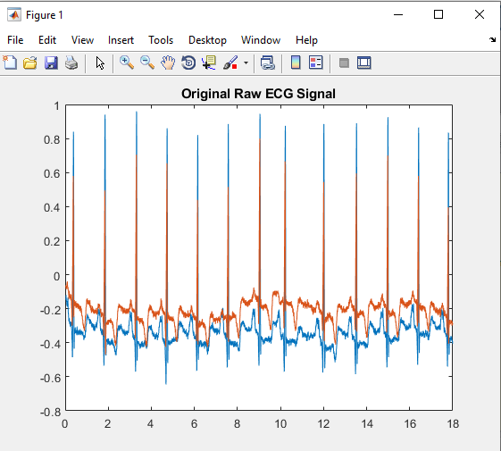

**Fig 7.1 Raw ECG Signal**

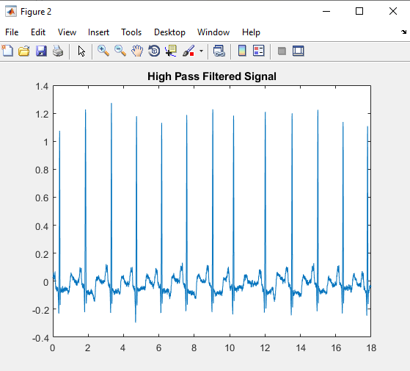

**Fig 7.2 Filtered through High Pass Filter**

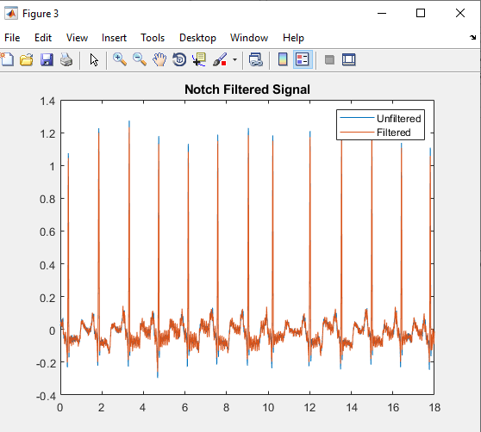

**Fig 7.3 Filtered with Notch Filter**

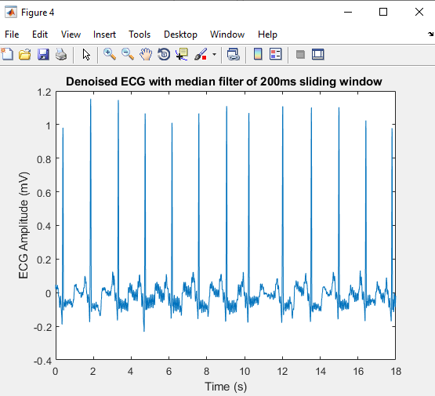

**Fig 7.4 Denoising of ECG with Median Filter of 200ms Sliding Window**

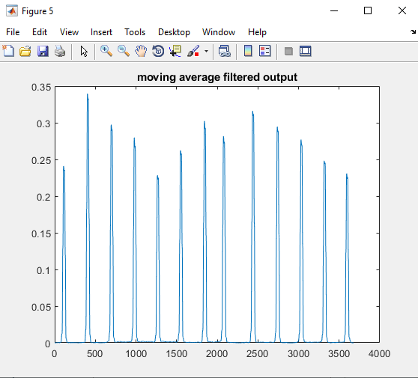

**Fig 7.5 Moving Average Filtered Output**

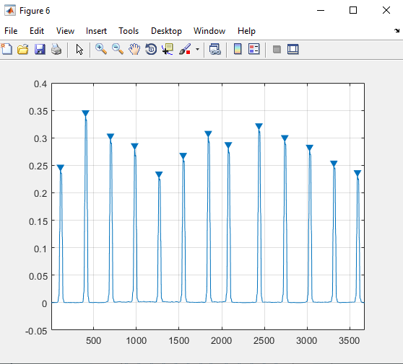

**Fig 7.6 Extracting Peaks from the filtered signal**

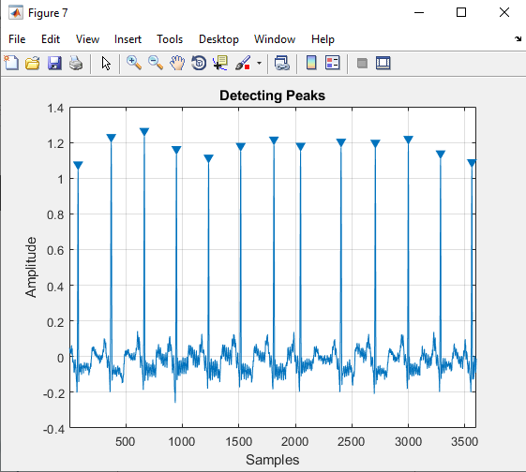

**Fig 7.7 Detected QRS Peaks from the filtered ECG Signal**

**CONCLUSION**

We can finally conclude that, the QRS peaks are extracted and detected using Statistical False Peak Elimination (SFPE) which employs a median filtering along with a moving average filter to filter out noise and interference terms from the original ECG signal and left out true peaks are sent to Selective. The SFPE uses the statistical analysis to threshold the QRS peaks that may be left out during the previous stage. The SFPE detects the QRS true peaks and later, a search back stage is employed which again detects for the any left out true peaks which makes the detection even more robust. The present technique of Statistical False Peak Elimination (SFPE) is employed along with a search back stage gives better detection results compared with the previous techniques.

**REFERENCES**

[1] T. Sharma and K. K. Sharma, ‘‘QRS complex detection in ECG signals using locally adaptive weighted total variation denoising,’’ Comput. Biol. Med., vol. 87, pp. 187–199, Aug. 2017.

[2] B.-U. Kohler, C. Hennig, and R. Orglmeister, ‘‘The principles of software QRS detection,’’ IEEE Eng. Med. Biol. Mag., vol. 21, no. 1, pp. 42–57, Aug. 2002R. Nicole, “Title of paper with only first word capitalized,” J. Name Stand. Abbrev., in press.

[3] K X. Lu, M. Pan, Y. Yu, QRS detection based on improved adaptive threshold, J. Healthc. Eng. 2018 (2018).

[4] R. M. Rangayyan, Biomedical Signal Analysis, 33, John Wiley & sons, 2015.

[5] J. Pan, W.J. Tompkins, A real-time QRS detection algorithm, IEEE Trans. Biomed. Eng. (3) (1985) 230-236.

[6] J.D. Drake, J.P. Callaghan, Elimination of electrocardiogram contamination from electromyogram signals: an evaluation of currently used removal techniques, J. Electromyogr. Kinesiol. 16 (2) (2006) 175-187.

[7] T. Sharma and K. K. Sharma, ‘‘QRS complex detection in ECG signals using locally adaptive weighted total variation denoising,’’ Comput. Biol. Med., vol. 87, pp. 187–199, Aug. 2017.

[8] B.-U. Kohler, C. Hennig, and R. Orglmeister, ‘‘The principles of software QRS detection,’’ IEEE Eng. Med. Biol. Mag., vol. 21, no. 1, pp. 42–57, Aug. 2002.

[9] R. M. Rangayyan, Biomedical Signal Analysis. Hoboken, NJ, USA: Wiley, 2015.

[10] X. Lu, M. Pan, and Y. Yu, ‘‘QRS detection based on improved adaptive threshold,’’ J. Healthcare Eng., vol. 2018, pp. 1–8, Mar. 2018.

[11] J. Pan and W. J. Tompkins, ‘‘A real-time QRS detection algorithm,’’ IEEE Trans. Biomed. Eng., vol. BME-32, no. 3, pp. 230–236, Mar. 1985.

[12] S. Kadambe, R. Murray, and G. F. Boudreaux-Bartels, ‘‘Wavelet transformbased QRS complex detector,’’ IEEE Trans. Biomed. Eng., vol. 46, no. 7, pp. 838–848, Jul. 1999.

[13] P. S. Gokhale, ‘‘ECG Signal de-noising using discrete wavelet transform for removal of 50 Hz PLI noise,’’ Int. J. Adv. Res. Technol., vol. 2, no. 5, pp. 81–85, May 2012.

[14] P. Sasikala and R. Wahidabanu, ‘‘Robust R peak and QRS detection in electrocardiogram using wavelet transform,’’ Int. J. Adv. Comput. Sci. Appl., vol. 1, no. 6, pp. 48–53, 2010.

[15] S. Pal and M. Mitra, ‘‘Detection of ECG characteristic points using multiresolution wavelet analysis based selective coefficient method,’’ Measurement, vol. 43, no. 2, pp. 255–261, Feb. 2010.

[16] Z. Zidelmal, A. Amirou, M. Adnane, and A. Belouchrani, ‘‘QRS detection based on wavelet coefficients,’’ Comput. Methods Programs Biomed., vol. 107, no. 3, pp. 490–496, Sep. 2012.

[17] H. A. N. Dinh, D. K. Kumar, N. D. Pah, and P. Burton, ‘‘Wavelets for QRS detection,’’ Australas. Phys. Eng. Sci. Med., vol. 24, no. 4, pp. 207–211, Dec. 2001.

[18] A. Sharma, S. Patidar, A. Upadhyay, and U. R. Acharya, ‘‘Accurate tunable-Q wavelet transform based method for QRS complex detection,’’ Comput. Electr. Eng., vol. 75, pp. 101–111, May 2019.

[19] S. Sahoo, P. Biswal, T. Das, and S. Sabut, ‘‘De-noising of ECG signal and QRS detection using Hilbert transform and adaptive thresholding,’’ Procedia Technol., vol. 25, pp. 68–75, Jan. 2016.

[20] D. Benitez, P. A. Gaydecki, A. Zaidi, and A. P. Fitzpatrick, ‘‘The use of the Hilbert transform in ECG signal analysis’’, Comput. Biol. Med., vol. 31, no. 5, pp. 399–406, Sep. 2001.